**VMV COMMERCE, JMT ARTS & JJP SCIENCE COLLEGE**

**(Institute of Computer Studies and Research)**

**Wardhaman Nagar, Nagpur-08.**

**Documentation for Final OJT Report**

1. **Cover Page (Paste on Bound Record)andFront Page (First page of report).**
2. **College Certificate**
3. **Company Certificate**

* Annexure 1- Undertaking Of Incumbency
* Annexure 2- Sample Personal Information Form
* Annexure 3- Letter Regarding Provision Of Services To The Organization
* Annexure 4- Relieving Letter Of Students
* Annexure 5- Student Work Diary (Nordic Format)
* Annexure 6- Attendance Sheet
* Annexure 7-Supervisor's Inter-Resident Evaluation Report
* Annexure 8-Student's Internship Experience: Feedback

1. **Declaration**
2. **Acknowledgement**
3. **Company Profile (Collect from Company)**
4. **Index Page**

**Contents ——————————**

**VMV COMMERCE, JMT ARTS & JJP SCIENCE COLLEGE**

**(Institute of Computer Studies and Research)**

**Wardhaman Nagar, Nagpur-08.**

A

OJT Report

On

“UPDATE PROFILE”

Submitted to

**Rashtrasant Tukadoji Maharaj Nagpur University, Nagpur**

In partial fulfillment of the requirement of

**Master of Commerce (Computer Management)**

**M.Com(CM)-ISEM-II**

**Developed *&*Submitted by**

Vaishnavi R. Shahare

Under the Guidance of

**Ms. P. M. Rasekar**

**2023-24**

**VMV COMMERCE, JMT ARTS & JJP SCIENCE COLLEGE**

**(Institute of Computer Studies and Research)**

**Wardhaman Nagar, Nagpur-08.**

**CERTIFICATE**

This is to certify that the project entitled “OJT Title” by “vaishnavi shshre“ in partial fulfillment of M.Com(CM)-- I (Master of Commerce (Computer Management), Sem-IIpost graduate diploma examination, had not been submitted for any other examination and does not form part of any other course undergone by the candidate.

### **It is further certified that he/she has completed his/her OJT work as per prescribed guidelines by Rashtrasant Tukadoji Maharaj Nagpur University, Nagpur.**

Dr. S. R. Karangutkar Dr. V. R. Bhedi

**Nodal Officer In-charge& HOD**

**Ms. P. M. Rasekar**

**Guide External Examiner**

**Place: Nagpur**

### **Date:**

**VMV COMMERCE, JMT ARTS & JJP SCIENCE COLLEGE**

**(Institute of Computer Studies and Research)**

**Wardhaman Nagar, Nagpur-08.**

**DECLARATION**

### **Ihere-by declare that the OJT entitled “Upadate Profile’’ has completed by me in partial fulfillment of M.Com(CM)-I, SEM-II post graduate diploma examination as prescribed by Rashtrasant Tukadoji Maharaj Nagpur University, Nagpur and had not been submitted for any other examination and does not form the part of any other course undergone by me.**

**Ms.Vaishnavi R. Shahare**

### **(M.Com(CM))**

### **Place:**

### **Date:**

**ACKNOWLEDGEMENT**

**With immense pride and sense of gratitude, I take this golden opportunity to express my sincere regards to the honorable In-charge and HOD Dr. V. R. Bhedi of institute for providing me facilities and inspiration to gather professional knowledge and material without which it would have been impossible to complete this hard task.**

**I am extremely thankful to my OJT Guide Ms. P. M. Rasekar**

**for her project guideline throughout the project. My sincere regards to her for giving me outstanding guidance, enthusiastic suggestions and invaluable encouragement which helped meto complete the project.**

**I will be failing in my duty if I do not thank the non-teaching staff of the college for their cooperation.**

**I would like to thank all who helped me in making this project complete and successful one.**

**Ms.Vaishnavi Shahare**

**(M.Com(CM))**

**INDEX**

|  |  |  |
| --- | --- | --- |
| SR.NO | **CONTENTS** | **PAGE NO.** |
|  | **INTRODUCTION**  1.1 EXISTING SYSTEM AND NEED FOR NEW SYSTEM  1.2 PROPOSED SYSTEM  1.3 SCOPE OF WORK |  |
|  | **PROBLEM DEFINITION**  2.2 PROBLEM DEFINITION |  |
|  | **ANALYSIS & DESIGN**  3.1 SYSTEM REQUIREMENTS  3.2 FRONT END & BACK END |  |
|  | **IMPLEMENTATION & RESULTS**  4.1 INPUT FORMS WITH DATA  4.2 OUTPUT REPORTS WITH DATA  4.3 SAMPLE CODE |  |
|  | **TESTING AND MAINTENANCE**  5.1TESTING  5.2VALIDATION  5.3MAINTENANCE |  |
|  | **USER MANUAL**  6.1 USER MANUAL |  |
|  | **CONCLUSION AND FUTURE SCOPE**  7.1 CONCLUSION  7.2 LIMITATIONS AND FUTURE SCOPE |  |
|  | REFERENCES |  |

**INTRODUCTION**

The "update profile" feature within a system or platform serves as a pivotal tool for users to manage and modify their personal information, preferences, and security settings. This functionality empowers users to ensure their profiles remain accurate, up-to-date, and reflective of their evolving needs and circumstances.

In essence, the update profile feature provides users with the autonomy and flexibility to tailor their profiles according to their preferences and requirements. Whether it involves changing contact details, updating preferences, or enhancing security measures, this feature offers users a seamless and intuitive interface to make necessary adjustments.

**Existing System:**

Static Profile Pages: The current system likely offers static profile pages where users can input their information during registration. However, once entered, this information remains stagnant unless users actively seek out profile settings to make changes.

Limited Customization: Users may have limited options for customization within their profiles. They might be able to update basic information like name, email, and perhaps a profile picture, but additional customization options may be lacking.

User Engagement Challenges: With static profiles, there might be challenges in engaging users to update their information regularly. This can lead to outdated profiles, which diminish the relevance and accuracy of user data across the platform.

Security Concerns: Depending on the existing system's architecture, there might be security concerns regarding the storage and handling of user data, especially if the platform lacks robust security measures for profile management.

**Need for a New System:**

Dynamic Profile Updates: There's a need for a system that allows for dynamic profile updates, enabling users to easily modify and update their information in real-time. This would ensure that profiles remain accurate and up-to-date, enhancing the overall user experience.

Enhanced Customization: Introducing a new system that offers enhanced customization options can empower users to personalize their profiles further. This might include options for adding more detailed information, selecting preferences, and showcasing achievements or interests.

Improved User Engagement: A new system should focus on improving user engagement by incentivizing and encouraging users to update their profiles regularly. This could be achieved through gamification elements, personalized recommendations, or notifications prompting users to review and update their information.

Enhanced Security Measures: Implementing robust security measures within the new system is crucial to safeguard user data and privacy. This includes encryption protocols, secure authentication mechanisms, and regular security audits to identify and address potential vulnerabilities.

Seamless Integration: The new system should seamlessly integrate with existing platform features and functionalities. This ensures a smooth transition for users and minimizes disruption to their overall experience while maximizing the benefits of the updated profile management system

**Proposed System:-**

A static update profile system typically involves a straightforward process for users to update their profile information without dynamic or real-time interactions. Here's a proposed system architecture for a static update profile feature:

1. Front End

User Interface (UI)

Design a user-friendly interface where users can view and edit their profile information. This interface should display all relevant fields for profile updates, such as name, contact details, bio, profile picture, etc.

Include input fields, dropdown menus, and buttons for users to input or select their information and submit their updates.

Static Web Pages

Develop static web pages using HTML, CSS, and JavaScript to create the front-end interface. Since the update profile feature is static, these pages do not require server-side rendering or dynamic content generation.

Ensure responsive design to support access from various devices, including desktops, tablets, and smart phones.

**SCOPE OF WORK:**

1. Requirements Gathering

Collect requirements from stakeholders, including users and system administrators, to understand what information can be updated, who can update it, and any specific rules or constraints.

2. Design and Architecture

Design the user interface for updating profiles, considering usability, accessibility, and consistency with the overall design language.

Define the backend architecture necessary to support profile updates, including database schema changes, APIs, and business logic.

3. Implementation

Develop frontend components for profile editing, such as forms, input fields, and validation mechanisms.

Implement backend functionality to handle profile update requests, including authentication, authorization, data validation, and storage.

4. Testing

Conduct unit tests to ensure the correctness of individual components.

Perform integration testing to verify the interaction between frontend and backend systems.

Conduct user acceptance testing (UAT) to validate that the profile update feature meets user expectations and requirements.

5.Security

Implement security measures to protect user data during the update process, including encryption, secure communication protocols, and access controls.

Perform security testing, such as penetration testing and code reviews, to identify and address vulnerabilities.

6. Documentation

Document the functionality of the profile update feature, including user instructions, system architecture, API documentation, and any configuration requirements.

7.Deployment

Deploy the updated profile feature to the production environment, ensuring compatibility with existing systems and minimizing downtime.

Monitor the deployment process to detect and address any issues promptly.

8. Maintenance and Support

Provide ongoing maintenance and support for the profile update feature, including bug fixes, performance optimization, and updates to accommodate changes in user requirements or technology.

By defining the scope of work comprehensively, the development team can effectively plan, execute, and deliver the profile update feature while meeting quality standards and stakeholder expectations.

**PROBLEM DEFINITION:-**

The problem definition of updating a profile typically involves improving or modifying existing user information within a system or platform. This process aims to ensure that the profile accurately reflects the user's current details, preferences, and any other relevant information.

Key aspects of the problem definition might include:

1. User Input:-

Define how users input changes or updates to their profiles. This could involve forms, direct editing, or other methods.

2. Data Integrity:-

Ensure that the system maintains data integrity throughout the update process, preventing errors or inconsistencies.

3. Authentication and Authorization:-

Establish mechanisms to verify the identity of users and ensure they have the appropriate permissions to update their profiles.

4. Validation:-

Implement validation checks to ensure that the data provided by users is accurate, complete, and meets any requirements or constraints.

5. Notification:-

Determine how users are informed about successful updates or any issues encountered during the process.

6. Security:-

Address security considerations to protect sensitive user information from unauthorized access or manipulation.

7. User Experience:-

Consider the user experience throughout the update process to make it intuitive, efficient, and user-friendly.

By defining these aspects clearly, developers and designers can create effective solutions for updating profiles that meet the needs of both users and the system.

**ANALYSIS & DESIGN :-**

SYSTEM REQUIREMENTS:-

HARDWARE:-

1. **Computer**:
   * A desktop or laptop computer is essential for web development tasks. Both Windows, macOS, or Linux-based systems are suitable for web development.
   * Ensure your computer has sufficient processing power, memory (RAM), and storage capacity to run development tools and store project files.
2. **Monitor**:
   * A high-resolution monitor or dual monitors can enhance productivity by providing ample screen space for coding, designing, and previewing web pages simultaneously.
3. **Input Devices**:
   * Keyboard and mouse (or trackpad) are standard input devices for interacting with the computer and performing coding and design tasks.
   * Some developers prefer using ergonomic keyboards or specialized input devices for increased comfort during extended coding sessions.
4. **Internet Connectivity**:
   * Reliable internet connectivity is necessary for accessing online resources, documentation, and collaboration tools. It's also required for testing web pages in various browsers and devices.

SOFTWERE:-

**Web Browser:-**

* google crome
* github
* boostrap

**Text Editor or Integrated Development Environment (IDE)**:

* Visual studio

**FRONT END :-**

The front end and back end of the update profile feature work together to provide users with a seamless experience for managing their profile information. Here's a breakdown of each component:

1. Front End

User Interface (UI)

The front end includes the user interface that users interact with to update their profiles. This typically consists of web pages or application screens where users can input or edit their personal information.

UI elements such as input fields, dropdown menus, buttons, and validation messages are designed to provide a smooth and intuitive experience for users.

Client-Side Logic

Client-side logic, often implemented using JavaScript frameworks like React, Angular, or Vue.js, handles user interactions and performs tasks such as form validation, data formatting, and updating the UI dynamically.

Real-time feedback and validation help users correct errors and ensure that their profile updates meet the required criteria before submission.

HTTP Requests

When users submit their profile updates, the front end sends HTTP requests to the back end server to process the data. These requests typically use REST full APIs or other communication protocols to transmit the user's changes securely.

**INPUT FORMS WITH DATA:-**

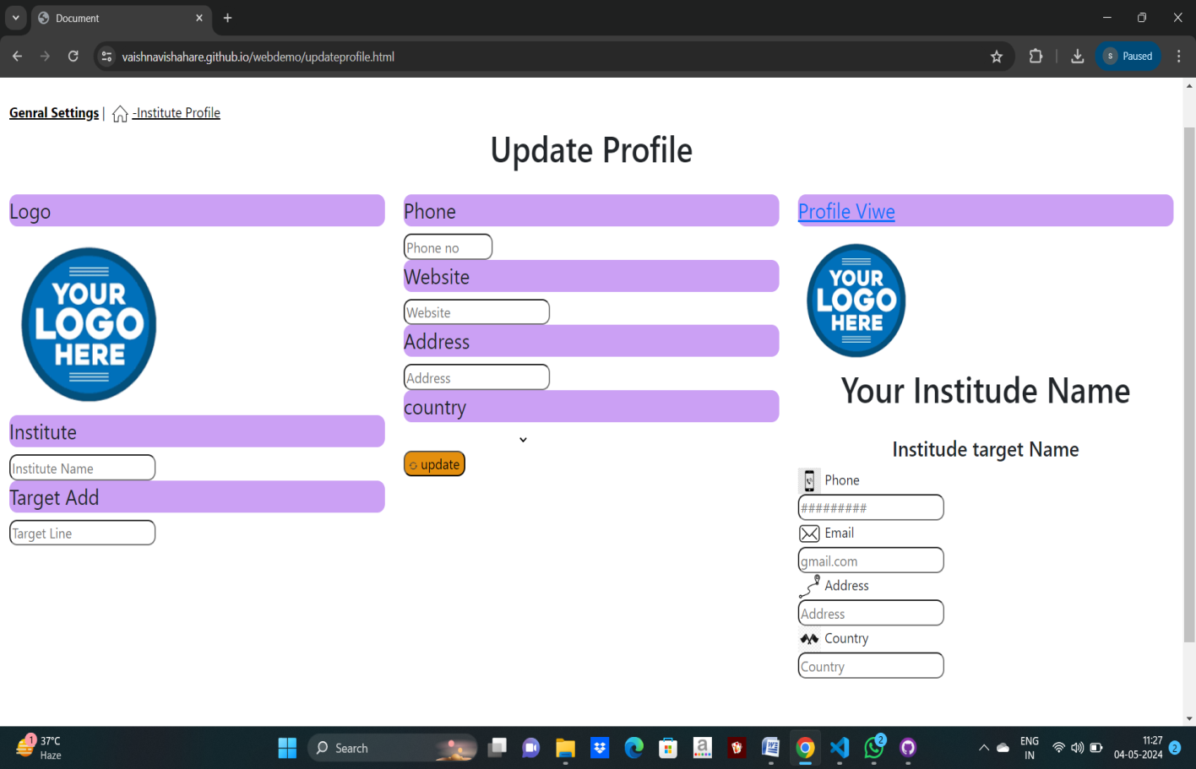

**OUTPUT REPORTS WITH DATA:-**

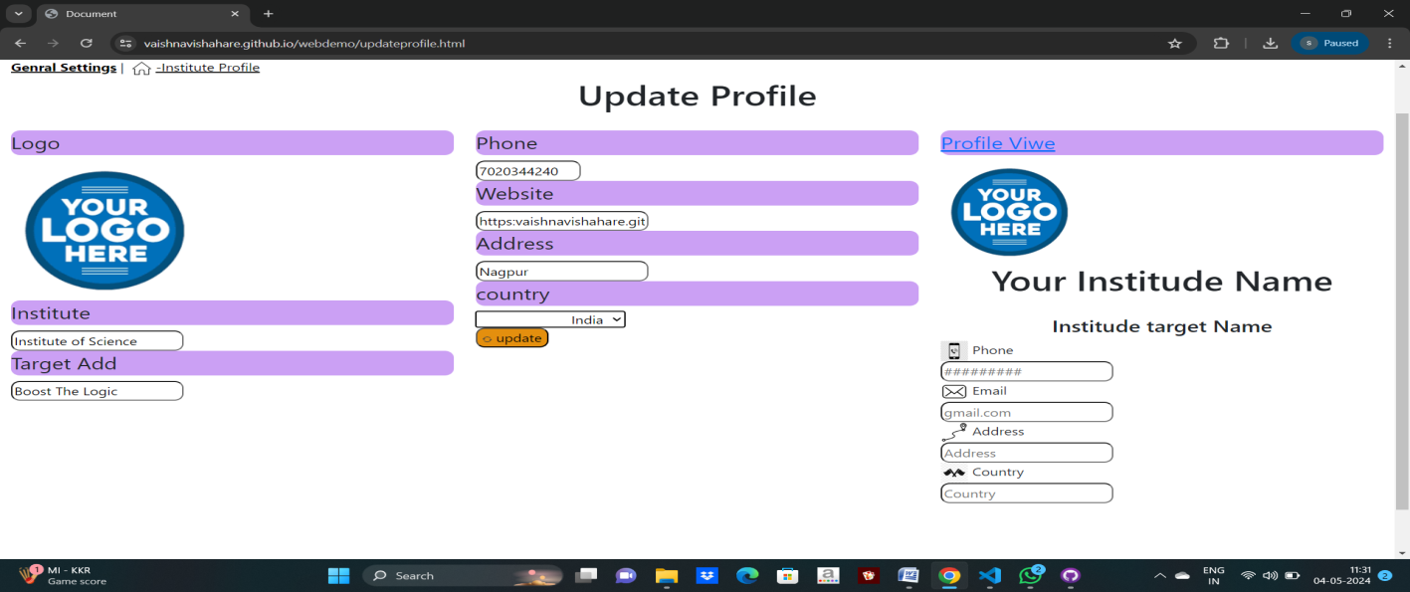

**SAMPLE CODE:-**

**Updateprofile.html:-**

<!DOCTYPE html>

<html lang="en">

<head>

<meta charset="UTF-8">

<meta name="viewport" content="width=device-width, initial-scale=1.0">

<title>Document</title>

<link rel="stylesheet" href="updateprofile.css">

<link href="https://cdn.jsdelivr.net/npm/bootstrap@5.3.3/dist/css/bootstrap.min.css" rel="stylesheet" integrity="sha384-QWTKZyjpPEjISv5WaRU9OFeRpok6YctnYmDr5pNlyT2bRjXh0JMhjY6hW+ALEwIH" crossorigin="anonymous">

<script src="https://cdn.jsdelivr.net/npm/bootstrap@5.3.3/dist/js/bootstrap.bundle.min.js" integrity="sha384-YvpcrYf0tY3lHB60NNkmXc5s9fDVZLESaAA55NDzOxhy9GkcIdslK1eN7N6jIeHz" crossorigin="anonymous"></script>

</head>

<body >

<div class="container-fluid" >

<div class="row">

<div class="col-12">

<nav class="navigation">

<a class="a" href="#"><b>Genral Settings</b></a> |

<a class="a" href="#"> <img src="home.png" alt="" height="30px" width="30px">-Institute Profile</a>

</nav>

<h1>Update Profile</h1>

</div>

</div>

<div class="row">

<div class="col-8">

<div class="row">

<div class="col-6">

<fieldset class="set">

<legend>Logo</legend>

<img src="logo.png" alt="logo" >

</fieldset>

<fieldset class="set">

<legend>Institute</legend>

<input type="text" placeholder="Institute Name">

</fieldset>

</fieldset>

<fieldset class="set">

<legend>Target Add</legend>

<input type="text" placeholder="Target Line">

</fieldset>

</div>

<div class="col-6">

<div class="split right">

<fieldset class="set">

<legend>Phone</legend>

<input type="tel" id="mobile" name="mobile" size="10" placeholder="Phone no">

</fieldset>

<fieldset class="set">

<legend>Website</legend>

<input type="url" placeholder="Website">

</fieldset>

<fieldset class="set">

<legend>Address</legend>

<input type="address" placeholder="Address">

</fieldset>

<fieldset >

<legend>country</legend>

<select name="Country" id="Country">

<option value=""></option>

<option value="India">India</option>

<option value="Korea">Korea</option>

<option value="UK">UK</option>

<option value="Japan">Japan</option>

</select>

</fieldset>

<button type="menu" name="update" value="update" ><img src="logobutton.png" alt="" height="10px" width="10px"> update</button>

</div>

</div>

</div>

<div class="row">

</div>

<div class="col-12">

</div>

</div>

<div class="col-4">

<fieldset class="set">

<legend ><a href="Profile Viwe" >Profile Viwe</a></legend>

<img src="logo.png" alt="logo" height="150px" width="150px" >

<h1>Your Institude Name</h1>

<h4>Institude target Name</h4>

<label for="phone"> <img src="phone.png" alt="phone" height="30px" width="30px"> Phone</label><br>

<input type="phone" placeholder="#########"><br>

<label for="email"> <img src="email.png" alt="email" height="30px" width="30px"> Email</label><br>

<input type="email" placeholder="gmail.com"><br>

<label for="address"> <img src="add.png" alt="address" height="30px" width="30px"> Address</label><br>

<input type="address" placeholder="Address"><br>

<label for="country"> <img src="country.png" alt="country" height="30px" width="30px"> Country</label><br>

<input type="country" placeholder="Country">

</fieldset>

</div>

</div>

</div>

</body>

</html>

updateprofile.css:-

nav a{

padding: 0%;

text-align: left;

color: black;

}

nav a img{

text-emphasis: none;

border-image-slice:40%;

}

h1{

text-align: center;

padding-bottom: 20px;

}

legend{

border-radius: 10px;

background-color: rgb(203, 160, 244);

border: 10px;

border-color: black;}

fieldset input{

border-radius: 10px;

padding-top: 1px;

padding-bottom: 1px;

}

select{

padding-left: 100px;

border: none;

}

.split .right{

height: 500%;

width: 30%;

position: fixed;

top: 0;

padding-top: 150px;

margin-left: 100px;

margin-right: 50px;

padding-right: 350px;

}

h4{

text-align: center;

}

.row{

margin-left: 50%;

}

.col-4{

padding-right: 100%;

}

button{

align-items: center;

}

.col-8 button{

background-color: rgb(228, 143, 14);

border-radius: 10px;

vertical-align: bottom;

}

.set{

border-radius: 10px;

border: black;

}

.container-fluid{

padding-left: 10%;

padding-top: 5%;

padding-bottom: 10%;

padding-right: 10%;

}

.row{

border-color: black;

}

**TESTING:-**

1.Functionality Testing

Verify that all fields in the profile can be updated individually.

Ensure that the changes made to the profile are saved correctly.

Test for any restrictions on the type of information that can be entered in each field (e.g., character limits, allowed characters).

Check if there are any required fields that must be filled out before updating the profile.

2. User Interface Testing

Check that the user interface is clear and intuitive, guiding the user through the profile update process.

Verify that error messages are displayed appropriately if the user enters invalid data or encounters any issues during the update process.

Ensure that the user is provided with confirmation messages after successfully updating their profile.

3. Security Testing

Test for any vulnerabilities such as injection attacks by attempting to input malicious data into the profile fields.

Verify that sensitive information, such as passwords or personal details, are handled securely during the update process.

4. Performance Testing

Test the performance of the update profile feature under various conditions, including different network speeds and system loads.

Ensure that the update process is fast and responsive, with minimal latency.

5. Compatibility Testing

Test the update profile feature across different devices (e.g., desktop, mobile, tablet) and browsers to ensure compatibility.

Verify that the feature works correctly on different operating systems and screen sizes.

6. Localization Testing

If the application supports multiple languages, test the update profile feature with different language settings to ensure that text and interface elements are translated accurately.

7. Regression Testing

Perform regression testing to ensure that the update profile feature did not introduce any new bugs or issues to existing functionality.

By following these guidelines, you can thoroughly test the update profile feature to ensure its reliability, usability, and security. Let me know if you need more specific guidance or have any questions!

**VALIDATION:-**

Validating the update profile functionality involves ensuring that the information provided by the user is accurate, consistent, and conforms to any specified criteria or constraints. Here's a validation process you can follow:

1.Required Fields

Check that all required fields are filled out before allowing the user to update their profile. Display clear error messages if any required fields are missing.

2. Data Format Validation

Validate the format of data entered in each field. For example:

Email address: Ensure it follows the standard email format.

Phone number: Validate against a standard phone number format.

Date of birth: Ensure it is a valid date and falls within an acceptable range.

Text fields: Check for excessive length, special characters, or inappropriate content.

3. Unique Constraints

If certain fields must be unique (e.g., username, email), verify that the entered value does not already exist in the system to prevent duplication.

4.Password Strength

If the update includes a password change, enforce password strength requirements such as minimum length, inclusion of special characters, numbers, etc.

5.Consistency Checks

Ensure consistency between related fields. For example:

If there's a "Confirm Email" field, ensure it matches the entered email address.

- If there's a "Confirm Password" field, ensure it matches the entered password.

6. Security Measures

Implement measures to prevent common security vulnerabilities, such as SQL injection, cross-site scripting (XSS), and cross-site request forgery (CSRF).

Sanitize user inputs to remove any potentially harmful characters or scripts.

7. User Feedback

Provide clear and informative error messages to guide users in correcting any invalid inputs.

Offer real-time validation where possible (e.g., indicating password strength as the user types).

8. Testing Edge Cases

Test edge cases, such as entering the minimum and maximum allowed values, to ensure the system behaves as expected.

Test with different languages, character sets, and locales to ensure compatibility and internationalization.

9. Performance Considerations

Validate that the validation process itself doesn't introduce significant overhead or latency, especially for large datasets or complex validation rules.

10. Accessibility

Ensure that error messages are accessible to users of assistive technologies and provide alternative methods for conveying validation feedback (e.g., ARIA attributes).

By thoroughly validating the update profile functionality, you can ensure data integrity, security, and a positive user experience.

**MAINTENANCE:-**

Maintaining the update profile functionality is crucial for ensuring that it remains effective, secure, and aligned with user needs over time. Here are some maintenance tasks to consider:

1. Regular Updates

Keep the update profile feature up-to-date with the latest technology standards, security patches, and user interface improvements. This may involve periodic software updates or version releases.

2. Bug Fixes

Monitor user feedback and bug reports to identify and address any issues or errors in the update profile functionality promptly.

3. Performance Optimization

- Continuously monitor and optimize the performance of the update profile feature to ensure fast response times and efficient use of system resources.

4. Security Enhancements

- Stay vigilant against emerging security threats and vulnerabilities by implementing robust security measures, such as encryption, access controls, and regular security audits.

5. Compliance Updates

Ensure that the update profile feature remains compliant with relevant regulations and standards, such as data protection laws (e.g., GDPR, CCPA) and industry-specific guidelines.

6. User Feedback Analysis

Gather and analyze user feedback on the update profile functionality to identify areas for improvement or new feature requests. Incorporate user suggestions to enhance the user experience.

7. Scalability Planning

Plan for scalability to accommodate potential increases in user traffic or data volume over time. Ensure that the update profile feature can scale seamlessly with growing demand.

8. Documentation Maintenance

Keep documentation for the update profile feature up-to-date, including user guides, API documentation, and internal developer documentation. This helps ensure that all stakeholders have access to accurate information.

9. Testing and Quality Assurance

Conduct regular testing and quality assurance checks to verify the stability, reliability, and functionality of the update profile feature, especially after making changes or updates.

10. Backup and Recovery Planning

Implement robust backup and recovery procedures to safeguard user data and ensure continuity of service in the event of system failures or data loss.

11. Training and Support

Provide ongoing training and support to users and administrators to help them effectively use and manage the update profile feature. Address any questions or issues promptly.

By proactively maintaining the update profile functionality, you can ensure its long-term effectiveness, security, and user satisfaction.

**USER MANUAL:**

Introduction:

Welcome to the user manual for updating your profile on [Website Name]. This guide will walk you through the steps to update your profile information on our static website.

Accessing the Profile Update Page:

1. Open your web browser and navigate to [Website URL].

2. Log in to your account using your username and password. If you don't have an account, you'll need to sign up first.

3. Once logged in, locate the "Profile" or "Account" section in the website's navigation menu.

Updating Your Profile:

1. Click on the "Profile" or "Account" link to access your profile page.

2. On the profile page, you will see your current information displayed, including your name, contact details, bio, and profile picture.

3. To update any of your profile information, look for the "Edit Profile" or "Update Profile" button/link.

4. Click on the "Edit Profile" or "Update Profile" button/link to enter the editing mode.

5. You will now see input fields or forms where you can make changes to your profile information.

6. Update the desired fields with the new information you want to save.

7. After making your changes, review them carefully to ensure accuracy.

8. Once you are satisfied with the updates, look for a "Save Changes" or "Update Profile" button.

9. Click on the "Save Changes" or "Update Profile" button to save your updates.

Confirmation and Feedback:

1. After saving your changes, you should see a confirmation message indicating that your profile has been updated successfully.

2. You can also verify your updated profile information by navigating back to your profile page and checking that the changes are reflected.

Troubleshooting:

If you encounter any issues or errors while updating your profile, double-check the information you entered for accuracy.

Ensure that all required fields are filled out correctly before saving your changes.

If the problem persists, you can contact our customer support team for assistance.

**CONCLUSION:-**

In conclusion, the update profile functionality serves as a vital tool for users to manage and customize their personal information within the system. By providing a user-friendly interface and robust set of features, the update profile feature empowers users to maintain accurate, up-to-date profiles tailored to their preferences and needs.

Through this functionality, users can effortlessly modify various aspects of their profiles, including contact details, preferences, and security settings. Whether it's changing a password, updating an email address, or refining personal preferences, the update profile feature offers flexibility and convenience while prioritizing data accuracy and security.

Overall, the update profile functionality plays a crucial role in enhancing user engagement, satisfaction, and trust by empowering users to manage their profiles efficiently and securely. With its intuitive interface, comprehensive features, and emphasis on data integrity, the update profile feature contributes to a seamless user experience and reinforces the system's commitment to user-centric design and functionality.

**LIMITATIONS AND FUTURE SCOPE:-**

While the update profile functionality offers significant benefits, it's important to acknowledge its limitations and consider opportunities for future improvement and expansion:

Limitations:

1. Data Privacy Concerns:

Despite security measures, there's always a risk of data breaches or unauthorized access to user information during the update process.

2. Limited Customization:

Some systems may have restrictions on the extent to which users can customize their profiles, limiting the range of options available for modification.

3. Technical Constraints:

Certain technical limitations, such as system architecture or integration with external platforms, may impose constraints on the update profile functionality.

4. User Experience Challenges:

Users may encounter difficulties navigating the update profile interface or understanding the process, leading to frustration and dissatisfaction.

Future Scope:

1. Enhanced Security Features:-

Implement additional security measures, such as multi-factor authentication or biometric verification, to enhance the security of the update profile functionality.

2. Advanced Customization Options:-

Expand the range of customization options available to users, allowing them to personalize their profiles more extensively based on their preferences and interests.

3. Integration with Third-Party Platforms:-

Explore opportunities to integrate the update profile functionality with external platforms or services, enabling seamless data synchronization and enhanced user experiences.

4. User-Centric Design Improvements:

Continuously improve the user interface and experience of the update profile feature through user testing, feedback analysis, and iterative design updates.

5. Automation and AI Integration:-

Incorporate automation and artificial intelligence capabilities to streamline the update process, anticipate user preferences, and offer personalized recommendations for profile updates.

6. Data Analytics and Insights:-

Leverage data analytics tools to gain insights into user behavior and preferences, informing future enhancements to the update profile functionality and overall system design.

7. Accessibility Enhancements:-

Ensure that the update profile feature is accessible to users with disabilities by implementing accessibility features and adhering to accessibility standards and guidelines.

8. Mobile Optimization:-

Optimize the update profile functionality for mobile devices, providing a seamless and intuitive experience for users accessing the system on smart phones and tablets.

By addressing these limitations and embracing future opportunities for improvement and expansion, the update profile functionality can evolve into a more robust, user-centric, and integral component of the system, contributing to enhanced user satisfaction, engagement, and loyalty.

# REFERENCES:-

* notes provide to protecnovet pvt.ltd.
* boostrap (webside)
* Google crome
* Github
* visual STUDIO
* <https://vaishnavishahare.github.io/webdemo/updateprofile.html>
* 